

**YEAR: 7**

**SUBJECT: SCIENCE**

**2023**

**TEST: Forces**

**TIME: 45 minutes**

**TOTAL MARKS: 39 marks**

**DO NOT WRITE ON OR MARK THIS PAPER**

**SECTION ONE – MULTIPLE CHOICE (10 marks)**

This section has **10** questions. Answer **all** questions on the separate multiple-choice answer sheet provided.

1. Force is measured in

a. kilograms

b. litres

c. tonnes

d. newtons

1. 2. Which of the following is a contact force?
   1. electrostatic
   2. magnetism
   3. friction

d. gravity

1. 3. Which of the following is ONLY a pulling force?
   1. electrostatic
   2. magnetism
   3. friction

d. gravity

4. The device that scientists use to measure forces is called a:

a. scale

b. spring balance

c. measuring cylinder

d. camera

1. 5. The arrows in the diagram represent the sizes of the forces acting on a stationary tennis ball. What will happen to the tennis ball?
2. it will stay still
3. it will accelerate downwards
4. it will accelerate upwards
5. it will move sideways

6. What can a force NOT do to an object?

1. increase the mass
2. accelerate or decelerate
3. change direction
4. change shape or size

7.What causes your hair to stand on end when you slide down a plastic slide at a park?

a. gravity

b. static electricity

c. magnetism

d. heat

8. When a mass experiences an unbalanced force it will?

1. move backwards
2. move forwards
3. move with constant speed
4. accelerate

9. Which of the following is the best example of a balanced force is:

a. two people playing tug-o-war with equal force

b. riding a bike up a steep hill on a windy day

c. skateboarding down a steep bumpy road

d. pushing a shopping trolley up an escalator with a broken wheel

10. A whiteboard marker is sitting at rest on your desk. Which of the following statements best describes this situation?

1. there are NO forces acting on the whiteboard marker.
2. The whiteboard marker pushes on the desk only.
3. the desk pushes up on the whiteboard marker only.
4. the forces acting on the whiteboard marker are balanced.

**END OF MULTIPLE CHOICE SECTION**

*Please continue with short answer section in the answer booklet*



**ANSWER BOOKLET**

**NAME:**

**FORM:** **DATE:**

**SECTION ONE:** Multiple choice answers

Cross (X) through the correct answer.

|  |  |  |  |  |
| --- | --- | --- | --- | --- |
| **1** | a | b | c | d |
| **2** | a | b | c | d |
| **3** | a | b | c | d |
| **4** | a | b | c | d |
| **5** | a | b | c | d |
| **6** | a | b | c | d |
| **7** | a | b | c | d |
| **8** | a | b | c | d |
| **9** | a | b | c | d |
| **10** | a | b | c | d |

Multiple Choice Short Answer Total

**/39**

**/29**

/25

**/10**

/2012

|  |  |
| --- | --- |
| **I CAN STATEMENT** | **QUESTIONS** |
| **MUST**  Draws diagrams which show forces on objects and predicts how unbalanced forces will affect an object’s motion. | 1, 2, 3, 4, 5, 6, 7, 9, 10, 11, 12, 13a, 14ab, 19 |
| **SHOULD**  Draws diagrams which show labelled forces on objects and predicts how unbalanced forces will affect an object’s motion. | 13 b, 14cd, 16, 18 |
| **COULD**  Draws diagrams which show forces of scaled length on objects and predicts in detail how unbalanced forces will affect an object’s motion. | 17, 15, 8 |

**SECTION TWO: Short Answer (29 marks)**

Answer the questions in the spaces provided.

1. **Classify** each of these actions as a push or pull force. (3 marks)
2. Sweeping the floor ____________________
3. Dragging a heavy sports bag along the floor ____________________
4. Throwing a cricket ball ____________________
5. Hitting a golf ball ____________________
6. Gravity acting on a skydiver ____________________
7. North pole of a magnet close to a South pole of another magnet ____________________
8. Use the word bank below to match the word to the definition. (5 marks)

|  |  |  |  |  |
| --- | --- | --- | --- | --- |
| Friction | Gravity | Magnetic | Spring Balance | Net Force |

|  |  |
| --- | --- |
|  | a force that pulls you down. |
|  | a force that pulls or pushes on other materials such as iron and other metals. |
|  | a force that opposes the motion of an object. |
|  | combination of all forces acting on an object. |
|  | a device used to measure forces. |

**13.** Johnny put 2 magnets close to each other. Describe what would happen if

a) Two North Poles were facing each other (1 mark)

|  |
| --- |
|  |

b) A North and a South Pole were facing each other (1 mark)

|  |
| --- |
|  |

**14.** This car is moving forward at a constant speed. Forces B and D acting on the car are equal in size.

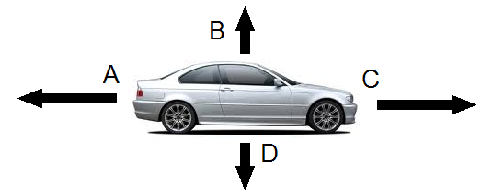

1. Draw the arrows on the car below to show it is accelerating (speeding up) (2 marks)

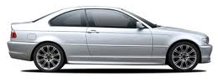

1. Draw arrows on the car below to show it is decelerating (slowing down) (2 marks)



c. Besides speeding up and slowing down. Can you identify another scenario in which the car is experiencing an unbalanced force? (1 marks)

_______________________________________________________________________________________________

______________________________________________________________________________________________________________________________________________________________________________________________

d. Identify two different ways in which shows that the car is experiencing a balanced force (2 marks)  
  
_______________________________________________________________________________________________

______________________________________________________________________________________________________________________________________________________________________________________________

**15**. Explain the difference between a contact and a non-contact force. Give an example of each. (2 marks)

_______________________________________________________________________________________________

______________________________________________________________________________________________________________________________________________________________________________________________

**16.** The figure below shows three blocks of wood resting on different surfaces. If you were to pull each by its hook, state which two blocks would move with the least friction and explain why you chose the blocks you did? (2 marks)



|  |
| --- |
|  |
|  |
|  |
|  |
|  |

**17.** Calculate the net force and direction of the following objects. Make sure you use correct units(3 marks)

|  |
| --- |
| **A**  **A** |
| **B**    **B** |
| **C**    **C** |

**18.** Jake has rubbed a balloon on his woollen jacket and placed on top of Sam’s head. Her hair stood up. Explain the reason behind this observation. (2 marks)

______________________________________________________________________________________________

_______________________________________________________________________________________________

_______________________________________________________________________________________________

_______________________________________________________________________________________________

_______________________________________________________________________________________________

**19.** Forces can be represented by arrows. (3 marks)

Compare the forces shown below by stating which:

* + 1. Force is the largest _______________________
    2. Two forces are the same size ______________________
    3. Two forces act in the same direction _____________________

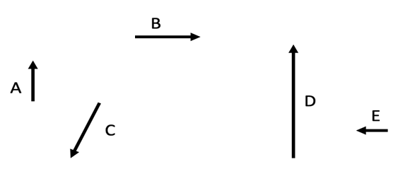

**END OF TEST**

**Please go back and check your work!**